# AI Assisted Coding – Assignment 7.1 – 1

# Lab 7: Error Debugging with AI – Systematic Approaches to Finding and Fixing Bugs

## Course Code - 24CS002PC215

## Course Title - AI Assisted Coding

## Year / Sem - II / I (2 – 1)

## Regulation - R24

## Date: 29-08-2025

## Student Name: G.Sanjansah

## Hall Ticket Number: 2503a52l20

## Student Mail-ID : [2503a52l20@sru.edu.in](mailto:2503a52l20@sru.edu.in)

Task 1 : Buggy Factorial Function.py

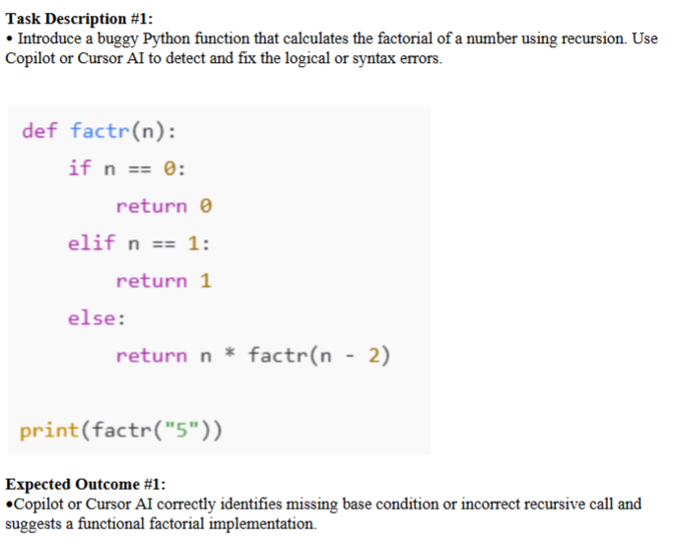

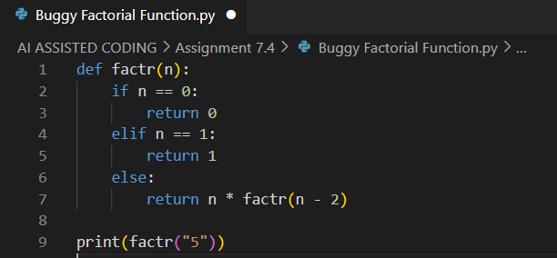

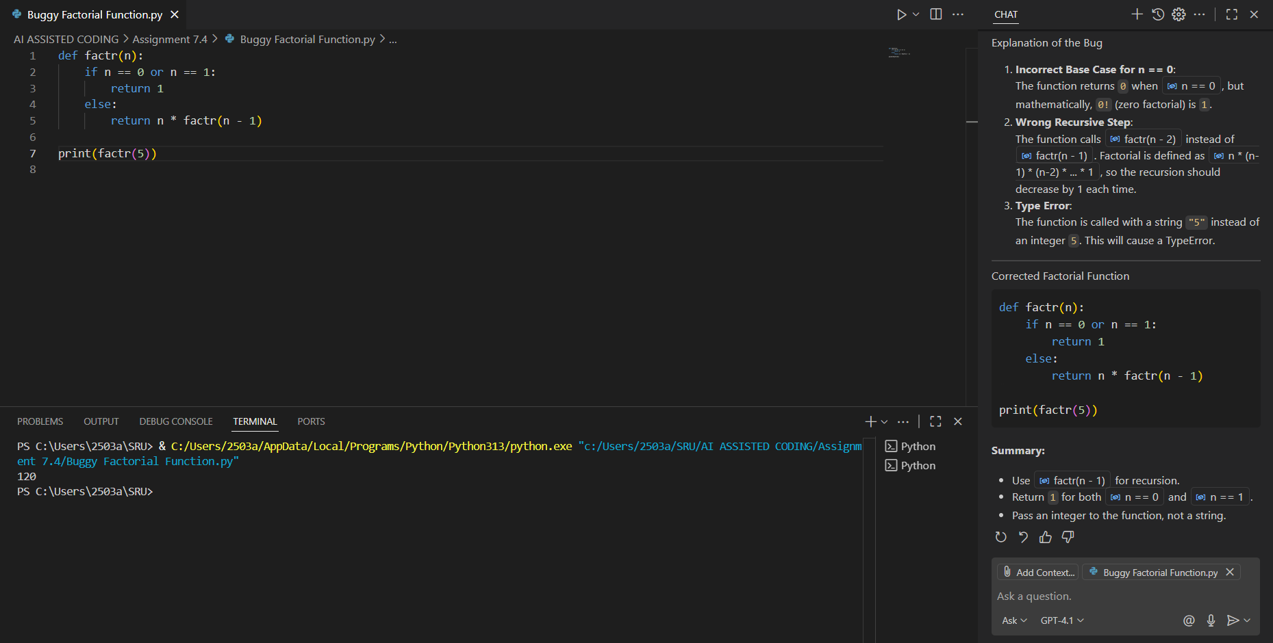

Task – 2 : List Sorting with Mixed Types

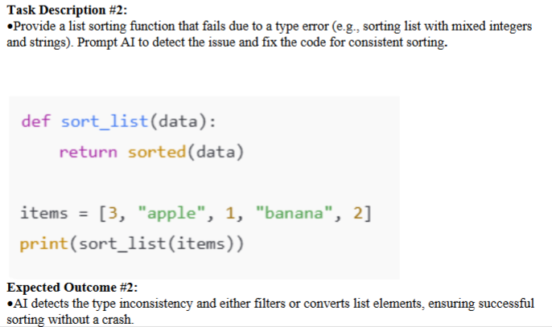

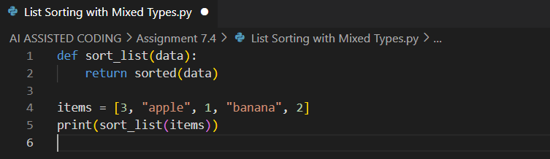

Task – 3 : File Handling without Closing

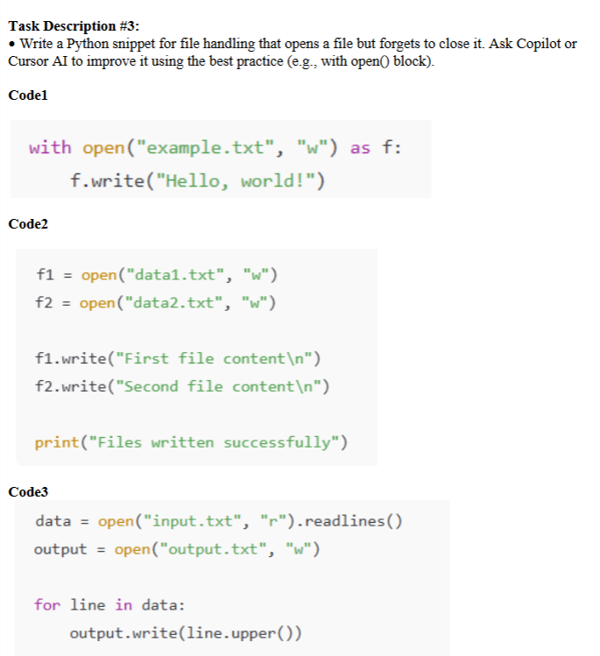

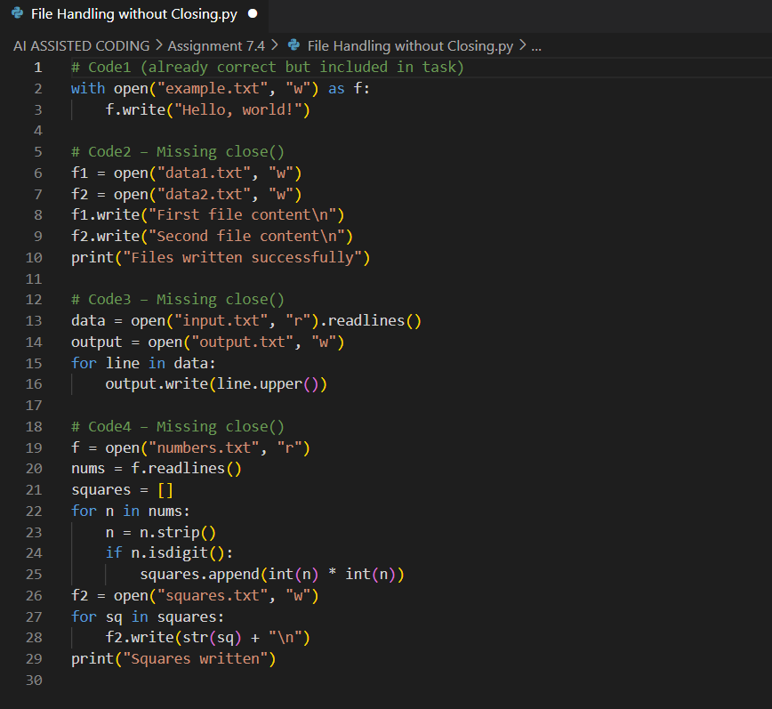

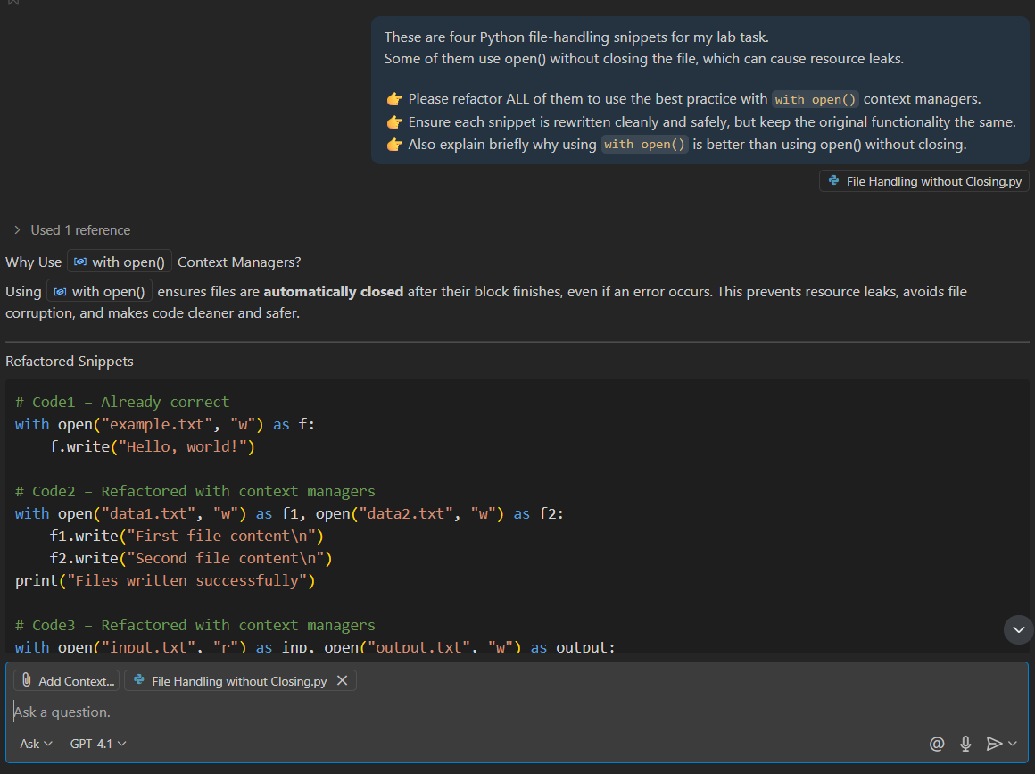

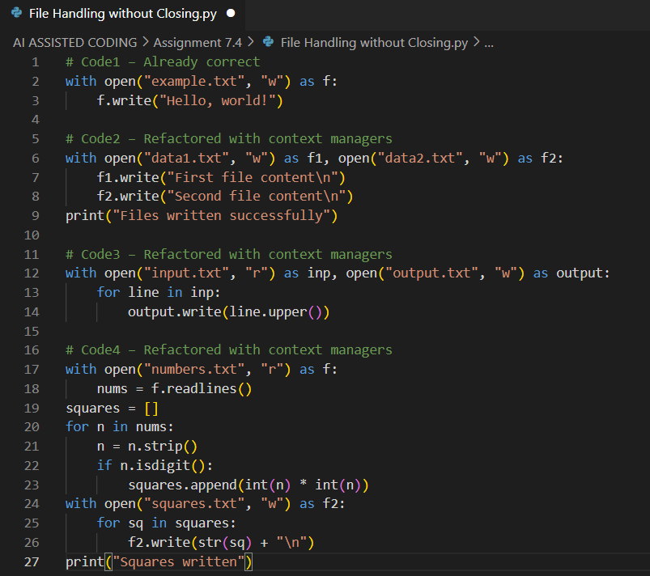

Task – 4 : ZeroDivisionError inside Loop

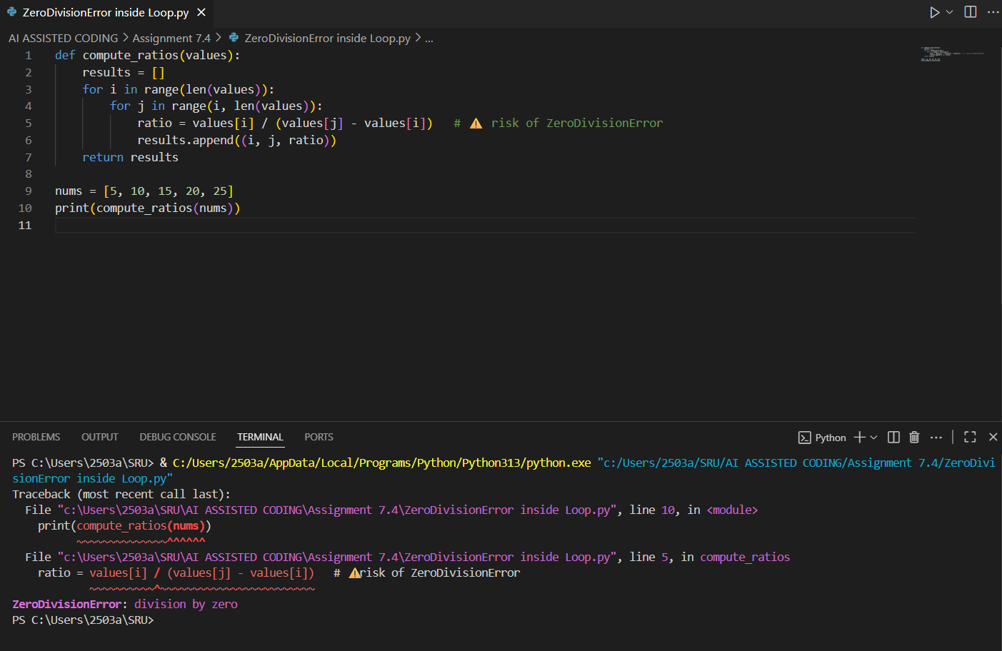

Task – 5 : Buggy Class Definition



